- WORK & FAMILY
- Updated August 29, 2012, 5:38 a.m. ET

A Worksheet for Math-Phobic Parents
- By SUE SHELLENBARGER
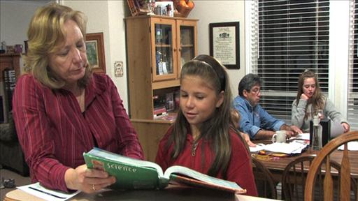
Parents who hate math often fear raising kids who will feel the same.
Many parents who loathe math fear raising kids who feel the same. This is becoming a more urgent concern as the fastest-growing occupations increasingly require skills in either math or science. Sue Shellenbarger on Lunch Break discusses how parents overcome math phobias.
Tammy Jolley is one of them—"a horrible math-phobic," she says. After struggling through algebra and statistics in high school and college, helping her 9-year-old son Jake with math homework makes her "feel like saying, 'Aaarghh, this is hard! I know why you don't get it,' " says the Madison, Ala., state-court official. Instead, she forces herself to encourage Jake.
Ongoing research is shedding new light on the importance of math to children's success. Math skill at kindergarten entry is an even stronger predictor of later school achievement than reading skills or the ability to pay attention, according to a 2007 study in the journal Developmental Psychology.
The issue is drawing increasing attention as U.S. teens continue to trail their global peers in math, performing below average compared with students in 33 other industrialized nations, based on the most recent results of the Program for International Student Assessment in 2010.
Parents play a pivotal role in kids' math attitudes and skills, starting in toddlerhood. Those who talk often to their youngsters about numbers, and explain spatial relationships in gestures and words, tend to instill better math skills at age 4, according to a long-term, in-home study of 44 preschoolers and their parents led by Susan C. Levine, a professor of psychology and comparative human development at the University of Chicago.
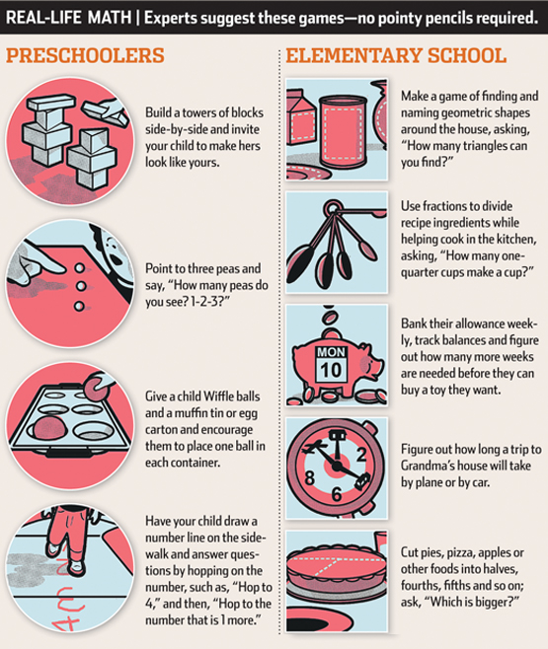
Jason Schneider
Yet many parents unconsciously teach children to fear math. A parent who reacts to a child's math questions or homework by saying, "I have never been good in math," or, "I haven't done math in 20 years," conveys to kids that math is daunting and they probably can't do it either, says Bon Crowder, a Houston-based teacher, tutor and publisher of MathFour.com, a website on math-teaching strategies.
It is possible for a math-phobic parent to raise a quant, but parents need to change their behavior, researchers and educators say. This means halting negative talk, mixing math games and questions into daily life just as they do reading and spelling, and encouraging kids to dive into tough math problems and not be afraid to struggle.
Encouraging children's instinctive curiosity is a good place twm wo start. Adam Riess, who won the 2011 Nobel Prize in physics, peppered his parents with questions about math as a child, and they treated his curiosity as natural. On car trips with his family at age 8, "instead of asking the proverbial, 'Are we there yet?' I'd look at mile markers and the speedometer and figure out how much time we needed to get there," says Dr. Riess, a professor of astronomy and physics at Johns Hopkins University. "Math seemed powerful to me."
Parents don't have to know math to help kids get off to a good start. Teaching youngsters to make connections between numbers and sets of objects—think showing a child three Cheerios when teaching the number three—helps children understand what numbers mean better than reciting strings of numbers by memory, Dr. Levine says. Doing puzzles together or using gestures to help describe spatial relationships such as "taller" and "shorter," can instill spatial abilities, which are linked to better math skills, she says.
Jason Schneider
Something as simple as playing with blocks side-by-side and encouraging a child to replicate your stacks and structures can teach spatial skills, says Kelly Mix, a professor of educational psychology at Michigan State University.
Although Fiona Cameron struggled with math in school, she is trying to teach her children Iain, 5, and Mhairi, 3, to enjoy it. Snuggling with them at bedtime, she encourages them to spot patterns in picture books, such as the "stripe-stripe-dot" on an eel, says Ms. Cameron, a Pasadena, Calif., financial adviser. She also poses daily problems from Bedtime Math, a nonprofit website launched last February to help parents integrate math into their children's lives.
The site posts a playful math question each day related to daily life and current events, such as the Olympics, and pushes "kids to wrestle with it in their heads, while talking with their parents about how to do it," says founder Laura Bilodeau Overdeck of Summit, NJ, a former high-tech strategy consultant.
Baking in the kitchen, Ms. Cameron explains fractions while having each of her children crack half the eggs. Filling muffin cups becomes a subtraction problem: "If we fill eight muffin cups and there are 12 in all, how many more do we have to fill?" Thanks to this "stealth math" approach, her kids are having fun solving problems, she says.
When kids start bringing math homework home, many parents have to break old habits of emphasizing good scores and grades, and praise them instead for trying hard and using multiple approaches to figure out problems. In Dr. Levine's study, 9-year-old children were more eager to tackle new math challenges if their parents focused on the process of problem-solving, rather than correct answers.
Struggling alongside your child can actually be helpful, says Suzanne Sutton, a Rockville, Md., math consultant and founder of NewtonsWindow.com, a website to help parents and students with math. A parent who is comfortable with trying and failing can teach a child how to look up things and grapple with challenges.
If you haven't a clue how to help, Ms. Crowder says, avoid voicing your anxiety or frustration. Instead, tell your child your time together would better be spent in other ways, and offer to get a tutor or another person to help.
Another option: Hire your child to tutor you in math. A parent asked Ms. Sutton years ago how to help her teenage son tackle a tough algebra course when she couldn't even understand the syllabus. Ms. Sutton told her to pick the toughest topic and offer to pay her son for writing a report on it and teaching it to her. The mother picked logarithms.
When her son gave her only a superficial explanation, Ms. Sutton says, the mother told him, "You didn't meet the terms of our agreement. I don't understand what it means." The teen dug deeper and tried again, and finally got the concept across to his mom, Ms. Sutton says.
Secure knowing that he had already mastered one of the toughest topics in the course, the teen went on to do well in the class.
Write to Sue Shellenbarger at sue.shellenbarger@wsj.com
A version of this article appeared August 29, 2012, on page D1 in the U.S. edition of The Wall Street Journal, with the headline: A Worksheet for Math-Phobic Parents.

