- Educating the Next Steve Jobs April 13, 2012, 6:18 p.m. ET

How can schools teach students to be more innovative? Offer hands-on classes and don't penalize failure

By TONY WAGNER
Most of our high schools and colleges are not preparing students to become innovators. To succeed in the 21st-century economy, students must learn to analyze and solve problems, collaborate, persevere, take calculated risks and learn from failure. To find out how to encourage these skills, I interviewed scores of innovators and their parents, teachers and employers. What I learned is that young Americans learn how to innovate most often despite their schooling—not because of it.
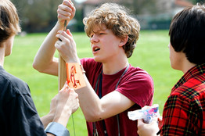
New Tech high school junior Kai Morgan in Napa, Calif., works on his trebuchet, a type of catapult. The school promotes 'independent learning.'
Though few young people will become brilliant innovators like Steve Jobs, most can be taught the skills needed to become more innovative in whatever they do. A handful of high schools, colleges and graduate schools are teaching young people these skills—places like High Tech High in San Diego, the New Tech high schools (a network of 86 schools in 16 states), Olin College in Massachusetts, the Institute of Design (d.school) at Stanford and the MIT Media Lab. The culture of learning in these programs is radically at odds with the culture of schooling in most classrooms.

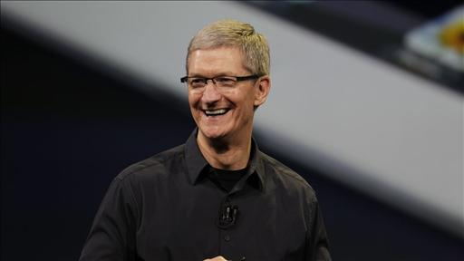
Apple CEO Tim Cook will be the opening night speaking at AllThingsD's D10 conference, Kara Swisher reports on digits. Photo: AP.
In most high-school and college classes, failure is penalized. But without trial and error, there is no innovation. Amanda Alonzo, a 32-year-old teacher at Lynbrook High School in San Jose, Calif., who has mentored two Intel Science Prize finalists and 10 semifinalists in the last two years—more than any other public school science teacher in the U.S.—told me, "One of the most important things I have to teach my students is that when you fail, you are learning." Students gain lasting self-confidence not by being protected from failure but by learning that they can survive it.
The university system today demands and rewards specialization. Professors earn tenure based on research in narrow academic fields, and students are required to declare a major in a subject area. Though expertise is important, Google's director of talent, Judy Gilbert, told me that the most important thing educators can do to prepare students for work in companies like hers is to teach them that problems can never be understood or solved in the context of a single academic discipline. At Stanford's d.school and MIT's Media Lab, all courses are interdisciplinary and based on the exploration of a problem or new opportunity. At Olin College, half the students create interdisciplinary majors like "Design for Sustainable Development" or "Mathematical Biology."
Learning in most conventional education settings is a passive experience: The students listen. But at the most innovative schools, classes are "hands-on," and students are creators, not mere consumers. They acquire skills and knowledge while solving a problem, creating a product or generating a new understanding. At High Tech High, ninth graders must develop a new business concept—imagining a new product or service, writing a business and marketing plan, and developing a budget. The teams present their plans to a panel of business leaders who assess their work. At Olin College, seniors take part in a yearlong project in which students work in teams on a real engineering problem supplied by one of the college's corporate partners.
In conventional schools, students learn so that they can get good grades. My most important research finding is that young innovators are intrinsically motivated. The culture of learning in programs that excel at educating for innovation emphasize what I call the three P's—play, passion and purpose. The play is discovery-based learning that leads young people to find and pursue a passion, which evolves, over time, into a deeper sense of purpose.
Mandating that schools teach innovation as if it were just another course or funding more charter schools won't solve the problem. The solution requires a new way of evaluating student performance and investing in education. Students should have digital portfolios that demonstrate progressive mastery of the skills needed to innovate. Teachers need professional development to learn how to create hands-on, project-based, interdisciplinary courses. Larger school districts and states should establish new charter-like laboratory schools of choice that pioneer these new approaches.
Creating new lab schools around the country and training more teachers to innovate will take time. Meanwhile, what the parents of future innovators do matters enormously. My interviews with parents of today's innovators revealed some fascinating patterns. They valued having their children pursue a genuine passion above their getting straight As, and they talked about the importance of "giving back." As their children matured, they also encouraged them to take risks and learn from mistakes. There is much that all of us stand to learn from them.
—Mr. Wagner, a former high-school teacher, is the Innovation Education Fellow at the Technology & Entrepreneurship Center at Harvard. His new book is "Creating Innovators: The Making of Young People Who Will Change the World."
A version of this article appeared April 14, 2012, on page C2 in some U.S. editions of The Wall Street Journal, with the headline: Educating the Next Steve Jobs.

