- AUGUST 31, 2011

Lessons From the One-Room Schoolhouse
- By SUE SHELLENBARGER
Before classes began at Spring Creek School near Decker, Mont., community volunteers cut back the grass, cleared tumbleweeds and made sure there were no rattlesnakes around the playground. Last week, the one-room schoolhouse opened for its six K-5 students.
"We all pitch in out here to support the school," says Loren Noll, a neighbor who showed up to dig weeds. Even though his 4-year-old daughter isn't old enough to attend, Mr. Noll volunteers as chairman of the school board.

A One-Room Schoolhouse
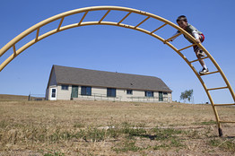
Janie Osborne for The Wall Street Journal
First grade student Caden Moreland climbed on playground equipment behind Spring Creek School in Decker, Mont.
- More photos and interactive graphics
In the U.S., 237 public schools had only one teacher, according to 2009 federal data, down from 463 in 1999. Most are located in remote areas. And while conditions are far from the rough-hewn rooms of "Little House on the Prairie," such schools often lack the amenities typically associated with high-quality schooling, such as computer labs, libraries, sports, art, music, nurses and psychologists.
Yet one-room schools often possess intangible assets that are rare in many bigger schools, says Marty Strange, policy director for the Rural School and Community Trust, a Washington, D.C., nonprofit. Students often build close relationships with teachers, pupils in mixed-age groups help each other learn, and parents and neighbors tend to get so deeply involved that the school becomes the center of community life.
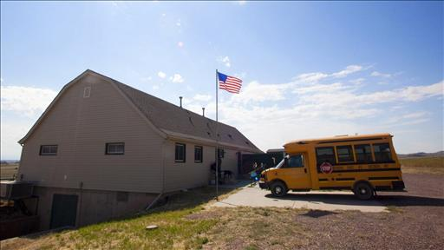
At Spring Creek, each grade has one or two kids. The lone teacher, Creighton Teter, makes as many as 30 daily lesson plans—four or five lessons for each child—along with grading papers and planning exercise and enrichment.
Sue Shellenbarger on Lunch Break looks at the few hundred remaining one-room schools still operating in the U.S., many lacking almost every modern educational amenity thought to be crucial, from classroom computers to in-person instruction.
He starts the school day by leading his students, ages 5 through 10, in a half hour of Zumba dance or other exercise. With the help of two aides, Mr. Teter then cycles small groups of one or two grades at a time through 20- to 30-minute lessons. Between lessons, the students practice skills or do homework or learning games at their desks. Fridays are reserved for field trips to swimming lessons and arts or museum programs, plus time at a gym—led, again, by Mr. Teter, a former high-school coach.
The Decker community—about 100 people—plays a big role. Everyone is invited to back-to-school night and other events—even if they don't have children. The school's bus driver deposits a newspaper published by the kids in all the mailboxes along her 150-mile daily route. And last year's Christmas pageant drew a standing-room-only audience of 60. "The school becomes a community center," Mr. Teter says.
At tiny Mist Elementary School in Mist, Ore., teacher Joanie Jones will welcome 23 students in kindergarten through fifth grade next week, with the help of one aide who doubles as custodian and a small army of volunteers. Mist Elementary lacks the reading instructors or lunch, music or physical-education programs offered by big schools. Yet Principal Aaron Miller says its students' test scores are higher than average in the 593-student district. More than 95% of third- through fifth-grade students at Mist Elementary met or exceeded state achievement standards in reading and math in the 2009-2010 year, the latest data available—well above the statewide average of 78.5% in math and 81% in reading.
Kimberly Scott, who runs a marketing business out of her home, volunteers weekly, teaching music and such subjects as science or cooking when needed. She taught students how to make rock crystals and electromagnets. For a lesson on the Pilgrims, Ms. Scott, who is among the eight regular volunteers at the school, taught them to cook traditional New England foods.
"That's how we survive here. Everybody helps each other out," Ms. Jones says.
Ms. Jones organizes the school day around individualized lesson plans for each student. She or her aide meets with students individually or in small groups throughout the day for about five minutes each time, reading or writing with them, reviewing their learning goals for the day or week, and helping them plan their next steps. Older students might be working on as many as 10 written goals in several subjects at a time.
Ms. Jones is able to include students' personal interests. A younger student interested in moths might learn to read and write about them, for example.
Volunteers may take aside half the students at a time for music or physical education. Others may help individuals with reading or writing.
Mackenzie Carr, 21, a former Mist Elementary student who in 2008 was valedictorian of her high-school class in nearby Vernonia, Ore., says an energetic volunteer who taught a weekly "Mad Science" class when she was in fifth grade helped inspire her to major in engineering in college.
The volunteer "came in wearing a lab coat with goggles on her head so her hair was poking out," and she drew the kids into hands-on science projects, Ms. Carr says. "The special attention" helped motivate her.
Enrollment at Cliff Island School, located off the coast of Maine, ranges from four to seven students in grades pre-K through 5. Its one teacher, Josh Holloway, has purchased science equipment by applying for grants. He uses videoconferencing to involve his students in book groups and programs at other schools.
The test scores of students on the 85-resident island are "very competitive with the top end" of average scores in the area's 11 elementary schools, says Jim Morse, superintendent of Portland Public Schools. Parents are so involved that "it's almost a throwback to the time when schools were an extension of the family."
Tiny schools have their drawbacks. A bad teacher can ruin a year, parents say. Some past students say the lack of sports or music programs put them so far behind their urban peers that they sat out those activities in high school.
- Ending a Start-Up, Seeking a Job
The transition to bigger schools can be difficult. Mist Elementary's Ms. Carr says adjusting to junior high was tough because of cliques in the larger school.
Still, small schools have unusual strengths. Students at one-room schools learn to work independently while the teachers are with others. And older students can reinforce their own learning if they help younger ones with lessons.
The Search Institute, a Minneapolis nonprofit, has compiled lists of 40 "developmental assets" kids need to thrive, such as safety and family support, based on 800 academic studies and surveys of three million students, says Gene Roehlkepartain, an executive vice president. About a quarter of these assets involve forming close bonds with adults outside the home, such as encouraging teachers and neighbors. These are opportunities tiny schools tend to offer, he says.
Former Spring Creek student Jaelyn Gibson, 18, recently graduated from high school with a 3.68 grade average and recalls how, years ago, neighbors and friends packed the school for her performance as a Christmas elf. "Everybody in the community came, whether they knew anybody in the school or not. It made me feel important, like, 'Wow, all these people actually came to see me,' " she says. "It kind of makes you feel good about yourself."

