Spiced Pumpkin Bread
Bon Appétit | November 1995
by Vern Bertagna: West Frankfort, Illinois
yield: Makes 2 loaves
Serve one of these loaves the day you make them. Wrap the other in foil and freeze up to one month so that you'll have it on hand for unexpected company.
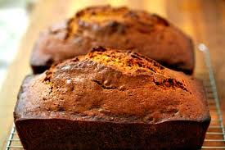

Ingredients
- 3 cups sugar
- 1 cup vegetable oil
- 3 large eggs
- 1 16-ounce can solid pack pumpkin
- 3 cups all purpose flour
- 1 teaspoon ground cloves
- 1 teaspoon ground cinnamon
- 1 teaspoon ground nutmeg
- 1 teaspoon baking soda
- 1/2 teaspoon salt
- 1/2 teaspoon baking powder
- 1 cup coarsely chopped walnuts (optional)

Preparation
Preheat oven to 350°F. Butter and flour two 9x5x3-inch loaf pans. Beat sugar and oil in large bowl to blend. Mix in eggs and pumpkin. Sift flour, cloves, cinnamon, nutmeg, baking soda, salt and baking powder into another large bowl. Stir into pumpkin mixture in 2 additions. Mix in walnuts, if desired.
Divide batter equally between prepared pans. Bake until tester inserted into center comes out clean, about 1 hour 10 minutes. Transfer to racks and cool 10 minutes. Using sharp knife, cut around edge of loaves. Turn loaves out onto racks and cool completely.
Read More http://www.epicurious.com/recipes/food/views/Spiced-Pumpkin-Bread-840#ixzz29eVNH326

